A farmer has 60 metres of unbroken fencing and wishes to use it for an animal pen.

[a] Determine the area of different polygons, starting with an isosceles triangle and rectangle, and then determine a generalisation for the relationship between the length L metres and n sides.

[b] Determine the optimum number of sides to give the maximum area.

[c] What would happen if the farmer replaced one side of the polygon with a sufficiently long straight line (not including the 60m)?

Include:

* Problem and context.
* Method.
* Calculations and interpretation of results with appropriate representation.
* Discuss whether the result is reasonable.

**Problem**: Determine the polygon with the optimum area for an animal pen.

**Context**: A farmer has 60m of unbroken fencing and wants to build an animal pen.

**Method**:

1. Determine an equation for the area of an isosceles triangle and rectangle to determine a generalisation for the maximum area of an n-sided polygon.
2. Determine a general formula for the maximum area of an n-sided polygon with a given perimeter.
3. Determine the limit of the maximum area of an n-sided polygon as the number of sides approaches infinity to find the maximum possible area with a given perimeter.
4. Determine an equation for the maximum area of an n-sided polygon with one side replaced with a sufficiently long straight line to find a generalisation.
5. Determine the limit of the maximum area of an n-sided polygon as the number of sides approaches infinity to find the maximum possible area with a given perimeter when one side is replaced with a sufficiently long straight line.

**Calculations**:

$P=60=2z+b$ → z = $\frac{60 - b}{2}$

$h=\sqrt{z^{2} – (\frac{b}{2})^{2}}$ = $\sqrt{(\frac{60 - b}{2})^{2}– (\frac{b}{2})^{2}}$

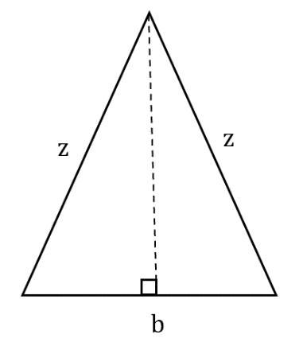 $A=$ $\frac{1}{2}$ x b x h = $\frac{1}{2}$ x b x $\sqrt{(\frac{60 - b}{2})^{2}– (\frac{b}{2})^{2}}$

h

CAS simplify → A = $\frac{b\sqrt{-30(b-30)}}{2}$

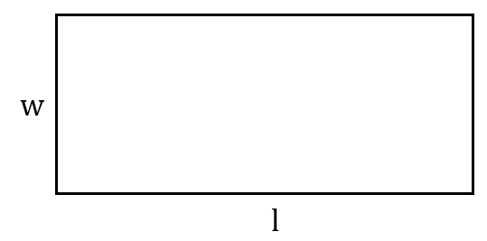

P = 60 = 2w + 2l → l = $\frac{60 - 2w}{2}$ = 30 – w

A = wl = w(30 – w) = 30w – w2

When n=3, A = $\frac{b\sqrt{-30(b-30)}}{2}$

CAS differentiate → A’ = $\frac{–(3\sqrt{30}b – 60\sqrt{30})}{4\sqrt{–x+30}}$

Local minimum/maximum is when the rate of change of the area (A’) is equal to 0.

$\frac{–(3\sqrt{30}b – 60\sqrt{30})}{4\sqrt{–x+30}}$ = 0

CAS solve → b=20

|  |  |  |
| --- | --- | --- |
| 20– | 20 | 20+ |
| + | 0 | – |

Therefore, b=20 is a local maximum.

z = $\frac{60 - b}{2}$ = $\frac{60 – 20}{2}$ = 20

When n=4, A = 30w – w2

CAS differentiate → A’ = –2w + 30

Local minimum/maximum is when the rate of change of the area (A’) is equal to 0.

–2w + 30 = 0

CAS solve → w = 15

|  |  |  |
| --- | --- | --- |
| 15– | 15 | 15+ |
| + | 0 | – |

Therefore, w=15 is a local maximum.

l = $\frac{60 - 2w}{2}$ = $\frac{50 - 2(15)}{2}$ = 15

**Generalisation of results**:

As both ‘z’ sides are equal, the maximum possible area for a 3-sided polygon is when all 3 sides of the triangle are equal to 20m. Thus, the maximum possible area for a 3-sided polygon is an equilateral triangle.

The maximum possible area for a 4-sided polygon is when the length and width are both equal to 15m. Thus, the maximum possible area for a 4-sided polygon would be a square.

It can be concluded for an n-sided polygon, the maximum possible area is when all the sides are of equal length to give the total given perimeter, assuming perimeter is kept constant.

**Calculations**:

l2 = r2 + r2 – 2r2cosθ = 2r2 – 2r2cosθ = 2r2(1 – cosθ)

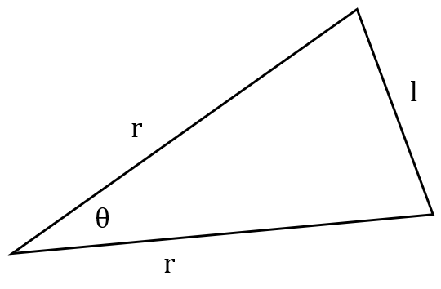r2 = → r = =

l = → r = =

θ = → r =

Area = r2sinθ x n = $\frac{1}{2}$ ($\frac{3600}{n^{2}(2(1 – cos(\frac{2π}{n}))}$)sin($\frac{2π}{n}$)n

CAS simplify → Area = $\frac{–900 sin(\frac{2π}{n})}{n cos(\frac{2π}{n})–n}$

General formula: Area = $\frac{– (\frac{L}{2})^{2} sin(\frac{2π}{n})}{n cos(\frac{2π}{n})–n}$

Where ‘L’ represents the perimeter of the n-sided polygon.

**Generalisation of results**:

Area = $\frac{–900 sin(\frac{2π}{n})}{n cos(\frac{2π}{n})–n}$

Where ‘n’ represents the number of sides of an n-sided polygon.

**Calculations**:

Finding the limit:

$$\lim_{n→∞}\left(\frac{–900sin\left(\frac{2π}{n}\right)}{n cos\left(\frac{2π}{n}\right)–n}\right)$$

CAS calculator → $$\lim_{n→∞}\left(\frac{–900sin\left(\frac{2π}{n}\right)}{ncos\left(\frac{2π}{n}\right)–n}\right)=\frac{900}{π}$$

**Generalisation of results**:

The limit for the maximum area of an n-sided polygon is $\frac{900}{π}$.

**Calculations:**

P = 60 = 2πr → r = $\frac{60}{2π}$ = $\frac{30}{π}$

Area of circle = πr2 = π x ()2 =

r

**Interpretation of results**:

The limit for the maximum area of an n-sided polygon is $\frac{900}{π}$ which is equal to the area of a circle. Therefore, the maximum area possible for a given perimeter would be when the shape is a circle.

This can be explained by the fact that as the number of sides of a regular polygon increases, the area of the polygon increases, and the shape becomes more and more like a circle. Therefore, the limit is the circle.

**~~Generalisation of results~~**~~:~~

~~The maximum possible area for an n-sided polygon with a given perimeter is a circle.~~

**~~Calculations~~**~~:~~

~~With one side replaced:~~

~~15~~~~2~~ ~~= y~~~~2~~ ~~+ y~~~~2~~ ~~– 2y~~~~2~~~~cosθ~~

y

y

15

15

15

15

15

~~θ = = 72 degrees~~

~~15~~~~2~~ ~~= y~~~~2~~ ~~+ y~~~~2~~ ~~– 2y~~~~2~~~~cos72~~

~~CAS solve → y =~~

~~y = 12.76 since y > 0~~

~~Area = x 12.76~~~~2~~ ~~x sin72 x 5 = 387.1074151~~

~~With no sides replaced:~~

~~12~~~~2~~ ~~= y~~~~2~~ ~~+ y~~~~2~~ ~~– 2y~~~~2~~~~cosθ~~

y

y

12

12

12

12

12

~~θ = = 72 degrees~~

~~12~~~~2~~ ~~= y~~~~2~~ ~~+ y~~~~2~~ ~~– 2y~~~~2~~~~cos72~~

~~CAS solve → y =~~

~~y = 10.21 since y > 0~~

~~Area = x 10.21~~~~2~~ ~~x sin72 x 5 = 247.7487457~~

12

~~With one side removed:~~

y

y

12

12

12

12

12

~~12~~~~2~~ ~~= y~~~~2~~ ~~+ y~~~~2~~ ~~– 2y~~~~2~~~~cosθ~~

~~θ = = 60 degrees~~

~~12~~~~2~~ ~~= y~~~~2~~ ~~+ y~~~~2~~ ~~– 2y~~~~2~~~~cos60~~

~~CAS solve → y =~~

~~y = 6.07 since y > 0~~

~~Area = x 6.07~~~~2~~ ~~x sin60 x 6 = 374.1229744~~

10

~~With no sides removed:~~

y

y

10

10

10

10

10

~~10~~~~2~~ ~~= y~~~~2~~ ~~+ y~~~~2~~ ~~– 2y~~~~2~~~~cosθ~~

~~θ = = 60 degrees~~

~~10~~~~2~~ ~~= y~~~~2~~ ~~+ y~~~~2~~ ~~– 2y~~~~2~~~~cos60~~

~~CAS solve → y =~~

~~y = 10 since y > 0~~

~~Area = x 10~~~~2~~ ~~x sin60 x 6 = 259.8076211~~

**Calculations**:

n = 4

P = 60 = 2w + l → l = 60 – 2w

l

A = lw = (60 – 2w)w

w

w

A’ = 0 → w = 15

l = 60 – 2(15) = 30

New area becomes 450

(twice that of when no sides are replaced)

Therefore, the area of a rectangle with one side replaced with a straight line is twice that of a rectangle with no sides replaced.

Disproven?

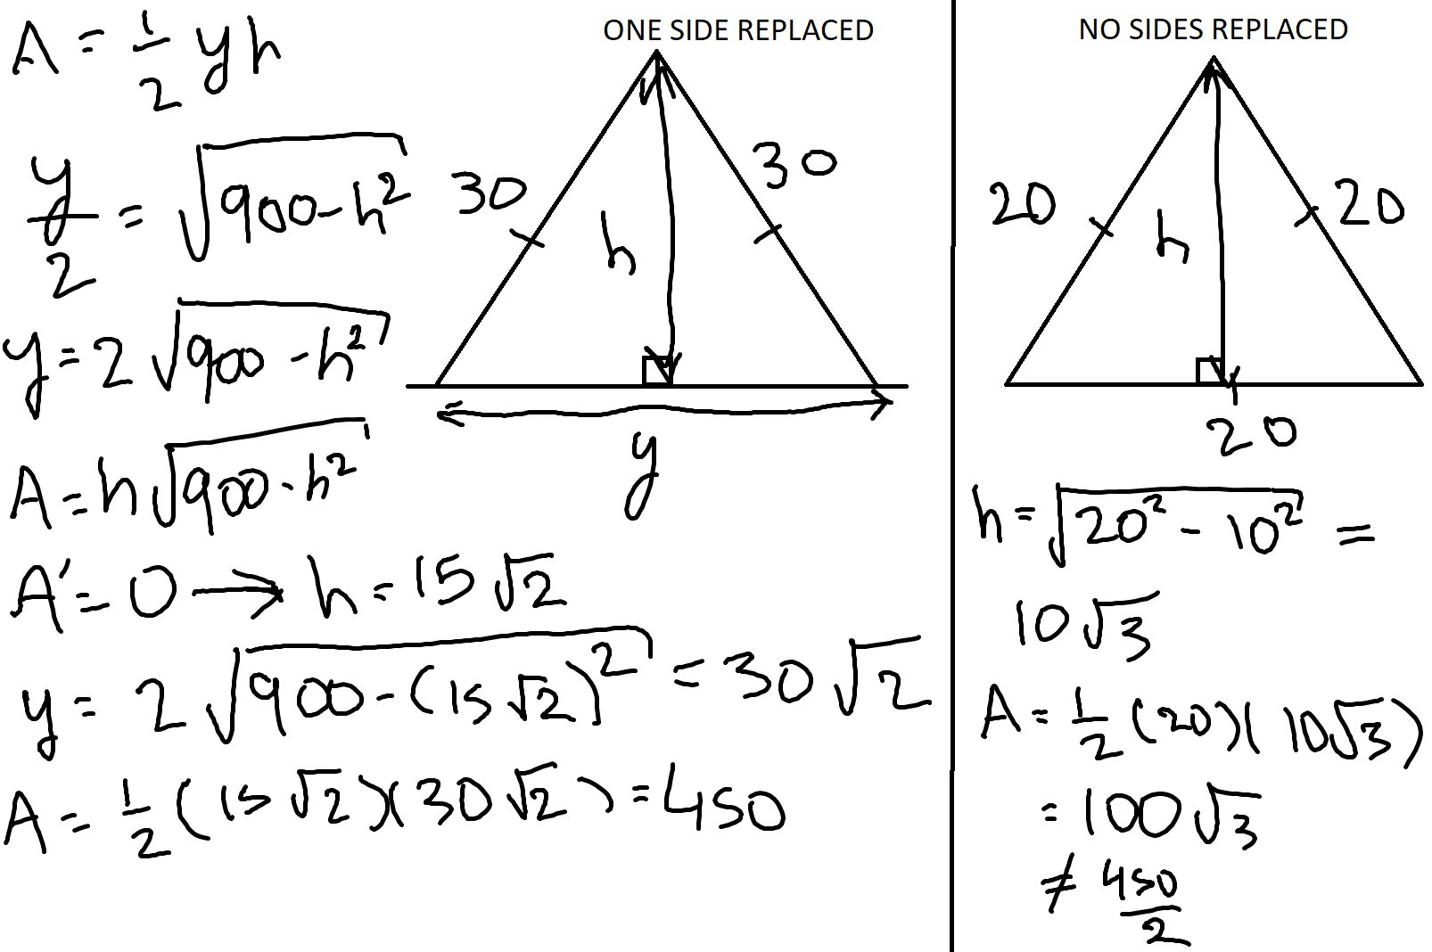

Circle:

P = 2πr → r = $\frac{P}{2π}$

Area = πr2 = π x =

Semicircle:

P = πr → r =

Area = πr2 = π()2 =

Therefore, the area of a circle with a line replaced (a semicircle) is twice that of a circle with no sides replaced (whole circle).

**Generalisation**:

When one side of a regular polygon is replaced with a sufficiently long straight line, the maximum area doubles.

General formula for the area of a regular polygon when perimeter is 60m:

Area = $\frac{–900 sin(\frac{2π}{n})}{n cos(\frac{2π}{n})–n}$

General formula for the area of a regular polygon with one line replaced with a sufficiently long straight line when perimeter is 60m:

Area = $\frac{–900 sin(\frac{2π}{n})}{n cos(\frac{2π}{n})–n}$ x 2

Determining the limit for a regular polygon (with no lines replaced):

CAS → $$\lim_{n→∞}\left(\frac{–900sin\left(\frac{2π}{n}\right)}{n cos\left(\frac{2π}{n}\right)–n}\right)=\frac{900}{π}$$

Determining the limit for a regular polygon with one line replaced:

CAS →

$$2 \lim_{n→∞}\left(\frac{–900sin\left(\frac{2π}{n}\right)}{n cos\left(\frac{2π}{n}\right)–n}\right)=\frac{1800}{π}$$

Semicircle area:

πr = 60 → r = $\frac{60}{π}$

Area = πr2 = π()2 =

**Analysis and interpretation of results**:

The limit for the maximum area when one side is replaced is the same as that of a semicircle. Therefore, the semicircle is the optimum shape as it gives the maximum area.

This can be explained by the fact that as the number of sides increases when one side is replaced with a sufficiently long straight line, it becomes more and more like a semicircle, therefore the semicircle is the limit.